Gary Glassman CPA

* Full Name : [**Gary Glassman CPA**](https://www.linkedin.com/in/gary-glassman-cpa-5bb7a28/overlay/about-this-profile/)
* Contact Number : 203-421-4401
* Current Position and Organization : Partner with Burzenski & Company, P.C.; Veterinary Financial Advisors
* Email : [gary@burzenski.com](mailto:gary@burzenski.com) , [garyglassman@gmail.com](mailto:garyglassman@gmail.com) , [Gary.Glassman@berrydunn.com](mailto:Gary.Glassman@berrydunn.com) , [kparker@berrydunn.com](mailto:kparker@berrydunn.com) , [Monica.DixonPerry@berrydunn.com](mailto:Monica.DixonPerry@berrydunn.com)

Gary focuses on the field of veterinary practice management, and specializes in financial management, operational consulting and tax planning for veterinary practices and their owners. He has extensive experience in the areas of practice valuation, related practice sale, merger and acquisition activity, structuring buy/sell agreements as well as hospital expansion and financing.

He is a member of the Veterinary Hospital Managers Association, American Animal Hospital Association and National Association of Certified Valuators & Analysts. He is a charter member of VetPartners™, the American Institute of Certified Public Accountants and the Connecticut Society of Certified Public Accountants. Additionally, he serves on the editorial board of Veterinary Economics magazine.

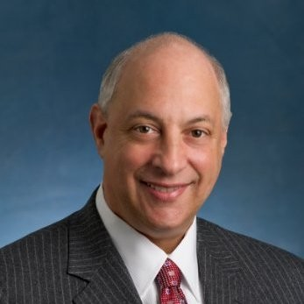

Copy of Christie Cornelius

* Full Name :[**Christie Cornelius**](https://www.linkedin.com/in/christiecornelius/overlay/about-this-profile/)
* Contact Number : N/A
* Current Position and Organization : Founder@ Kindred.Vet | Executive MBA | Doctor of Veterinary Medicine
* Email : [christie.cornelius2004@gmail.com](mailto:christie.cornelius2004@gmail.com)

As a seasoned veterinarian with a robust entrepreneurial spirit, I bring a unique blend of clinical expertise, business acumen, and innovative thinking to the veterinary industry.

My journey began with a passion for providing high-quality care to pets and their families, which led me to specialize in palliative care and in-home pet euthanasia - a practice that has been warmly received by the communities I serve.

I hold an executive MBA from Rice University, where I honed my strategic leadership and business management skills. This education has equipped me to navigate the complexities of the veterinary business landscape and drive meaningful change in the industry.



Tab 3